|  |  |
| --- | --- |
| Date | 22 September 2022 |
| Team ID | PNT2022TMID47456 |
| Project Name | SMART WASTE MANAGEMENT FOR METROPOLITIEN CITIESS |
| Maximum Marks | 2 Marks |

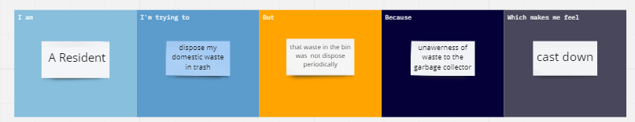

|  |  |  |  |  |  |
| --- | --- | --- | --- | --- | --- |
| **Problem Statement (PS)** | **I am (Customer)** | **I’m trying to** | **But** | **Because** | **Which makes me feel** |
| PS-1 | A Resident | Dispose my domestic waste in trash | That waste in the bin was not dispose periodically | Unawareness of waste to the garbage collector | Cast down |
| PS-2 | Entrepreneur | Dispose large amount waste material in safety manner | Sometimes dispose of waste by the truck is unpredictable per day | information about waste not reached to the collector properly | Obsessed |

PS-2